Ivy Truong

CSCI 3287

Homework 1

Part 4 Queries and Results

1.Retrieve the name, club, and position for the players whose country is “USA”.

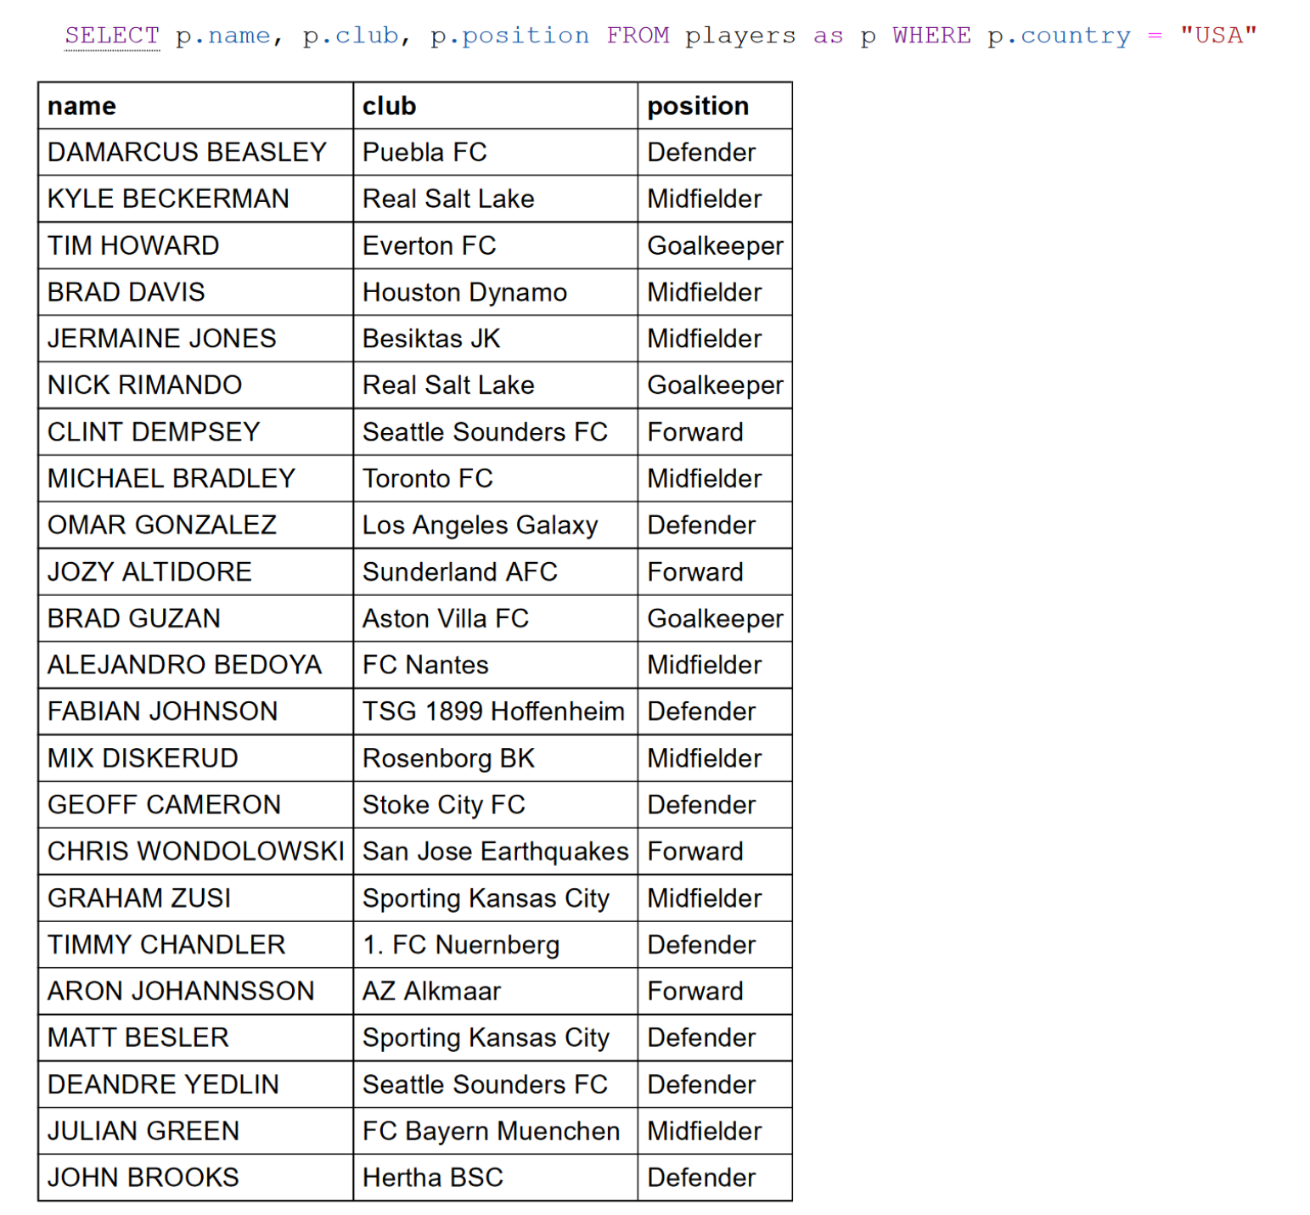

2. Retrieve the names of the countries participating in the 2014 world cup that have won the world cup at least once.

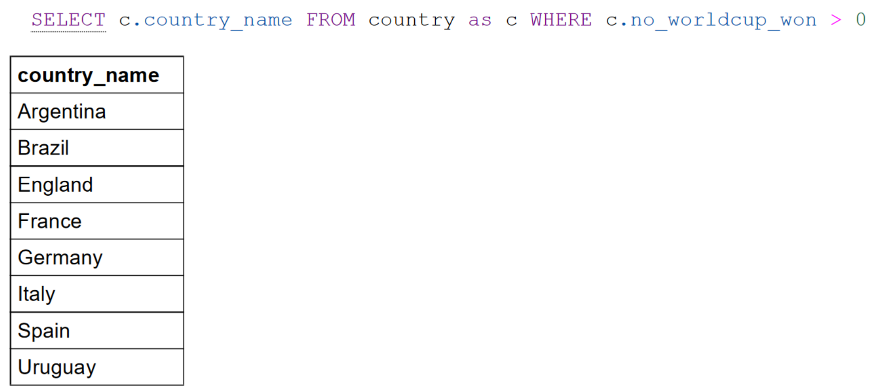

3. Retrieve the names of the countries participating in the 2014 world cup that have never won the world cup.

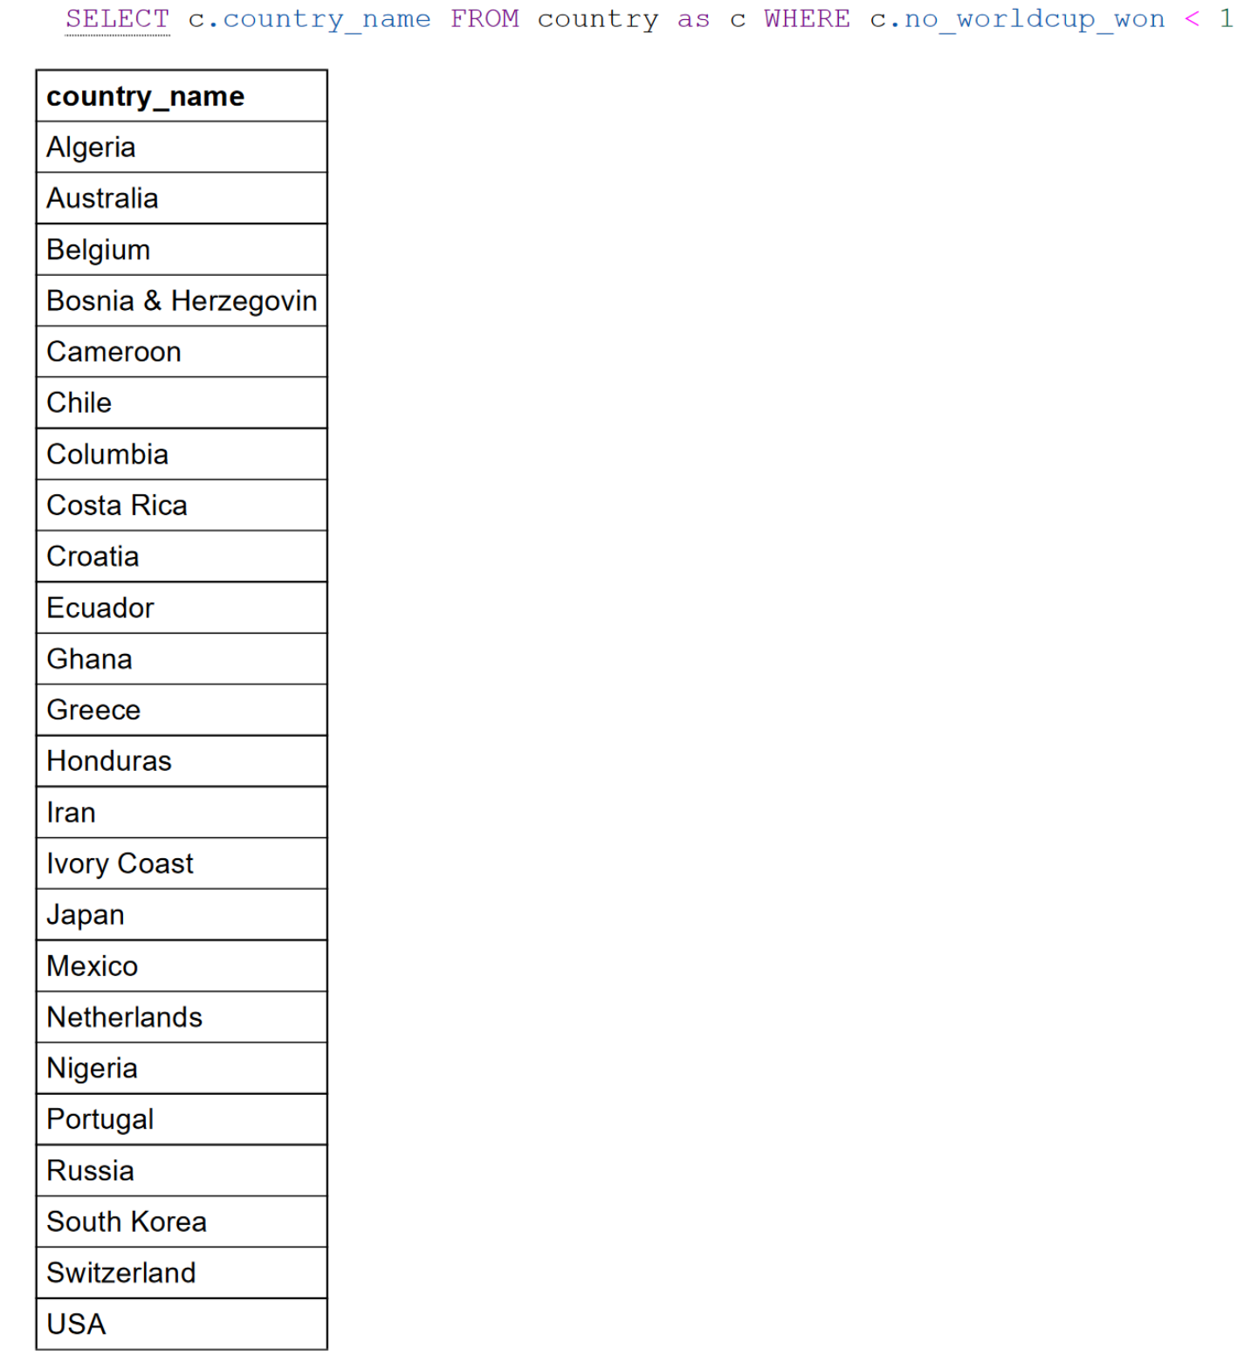

4. Retrieve the name and the country of the player with the most yellow cards in the 2014 world cup.

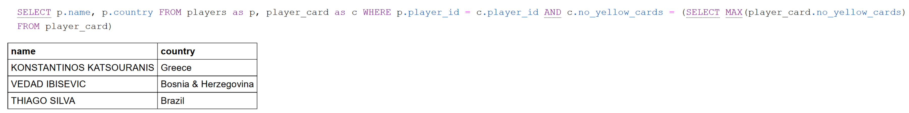

5. For every host city, retrieve the host city and the number of games played in that city.

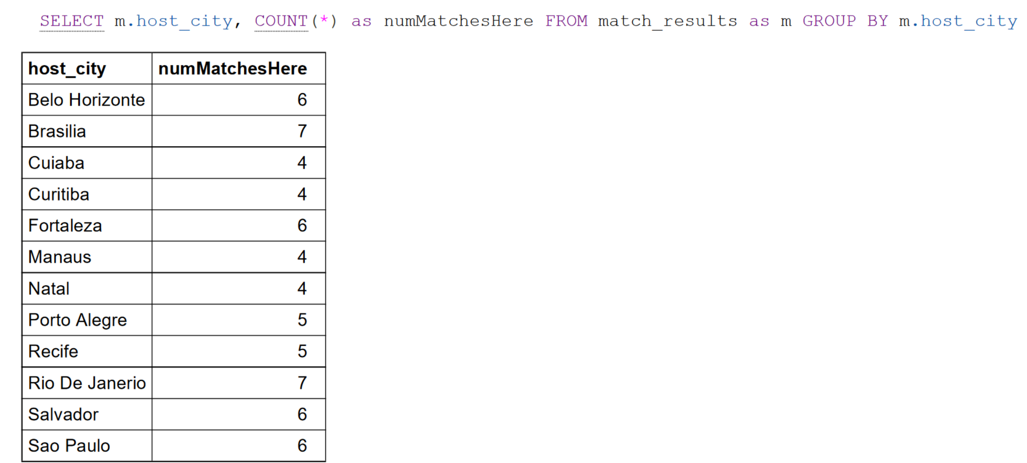

6. For each country, retrieve the country name and the number of games they played as team 1, the total goals scored of team 1 and the total goals scored of team 2 (the teams they went against).



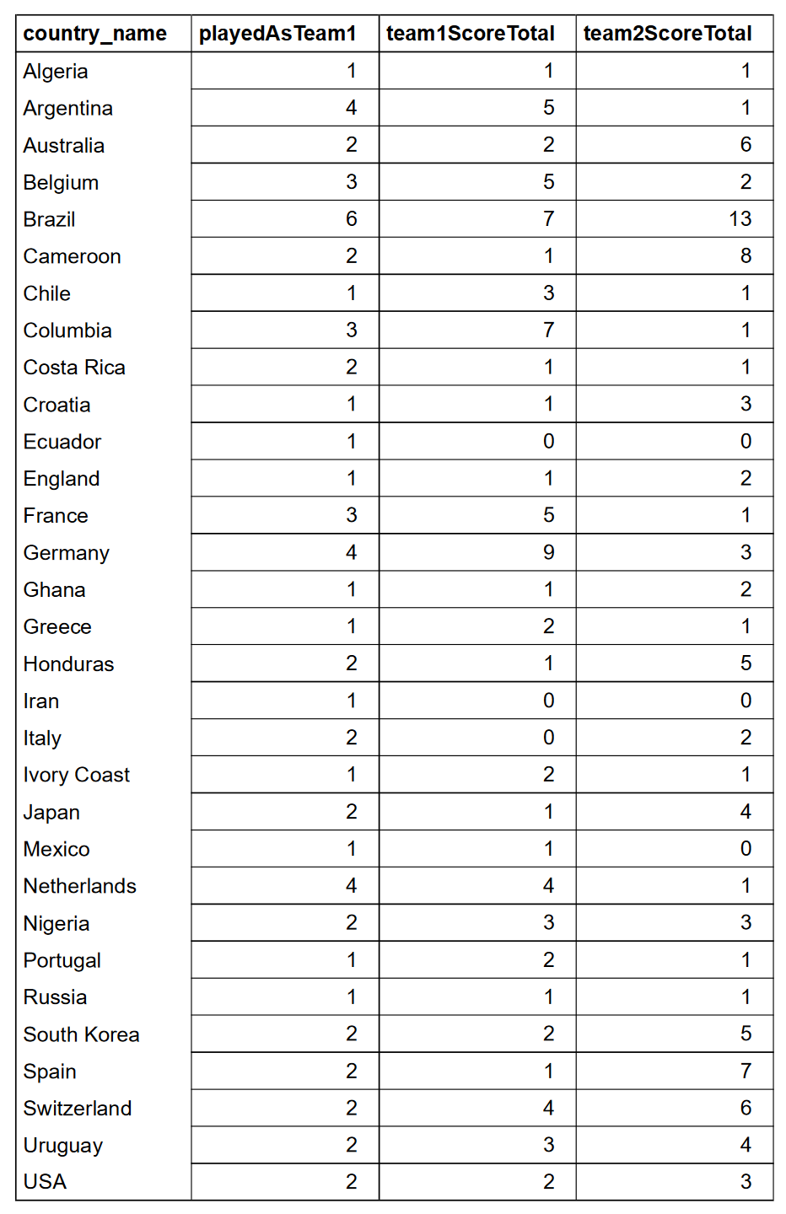

7. For each country, retrieve the country name and the number of games they played as team 2, the total goals scored of team 2 and the total goals scored of team 1 (the teams they went against).



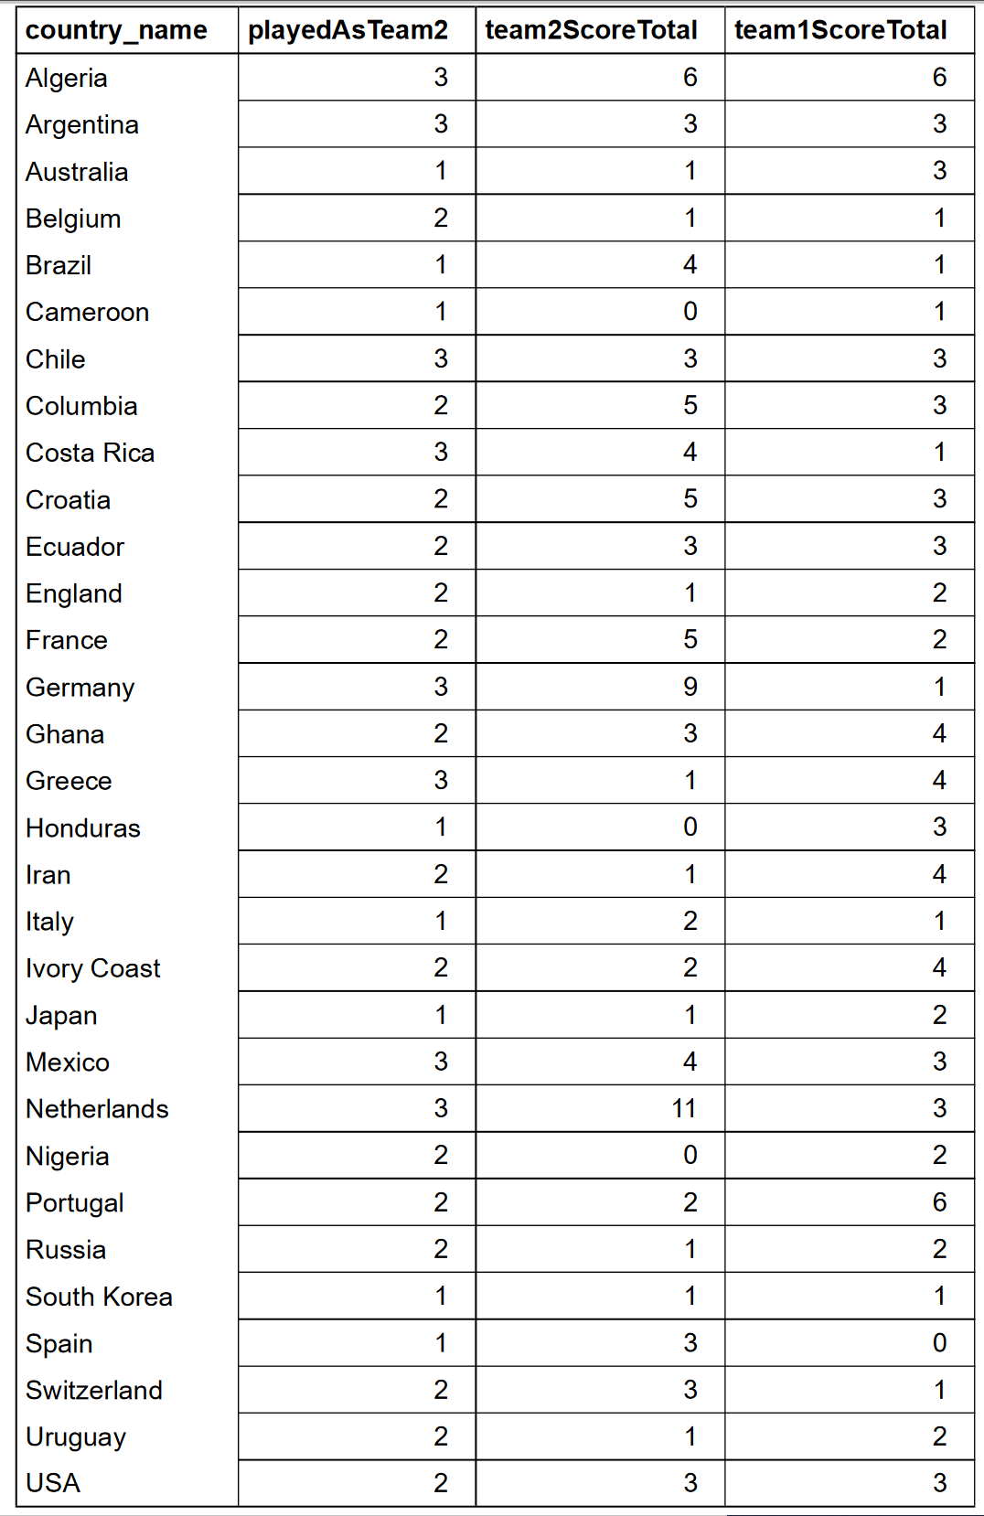

8. Find all the matches played with the country ‘Brazil’ as team 1 or team 2.

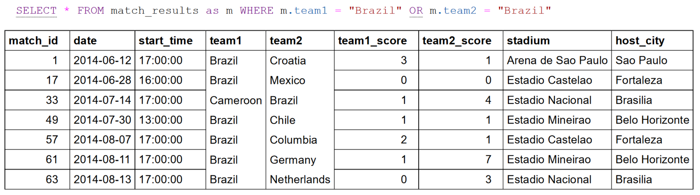

9. Retrieve the name of the players who have scored at least 1 goal, the player’s country, and the number of goals each player scored. Order the results by the number of goals scored in descending order.



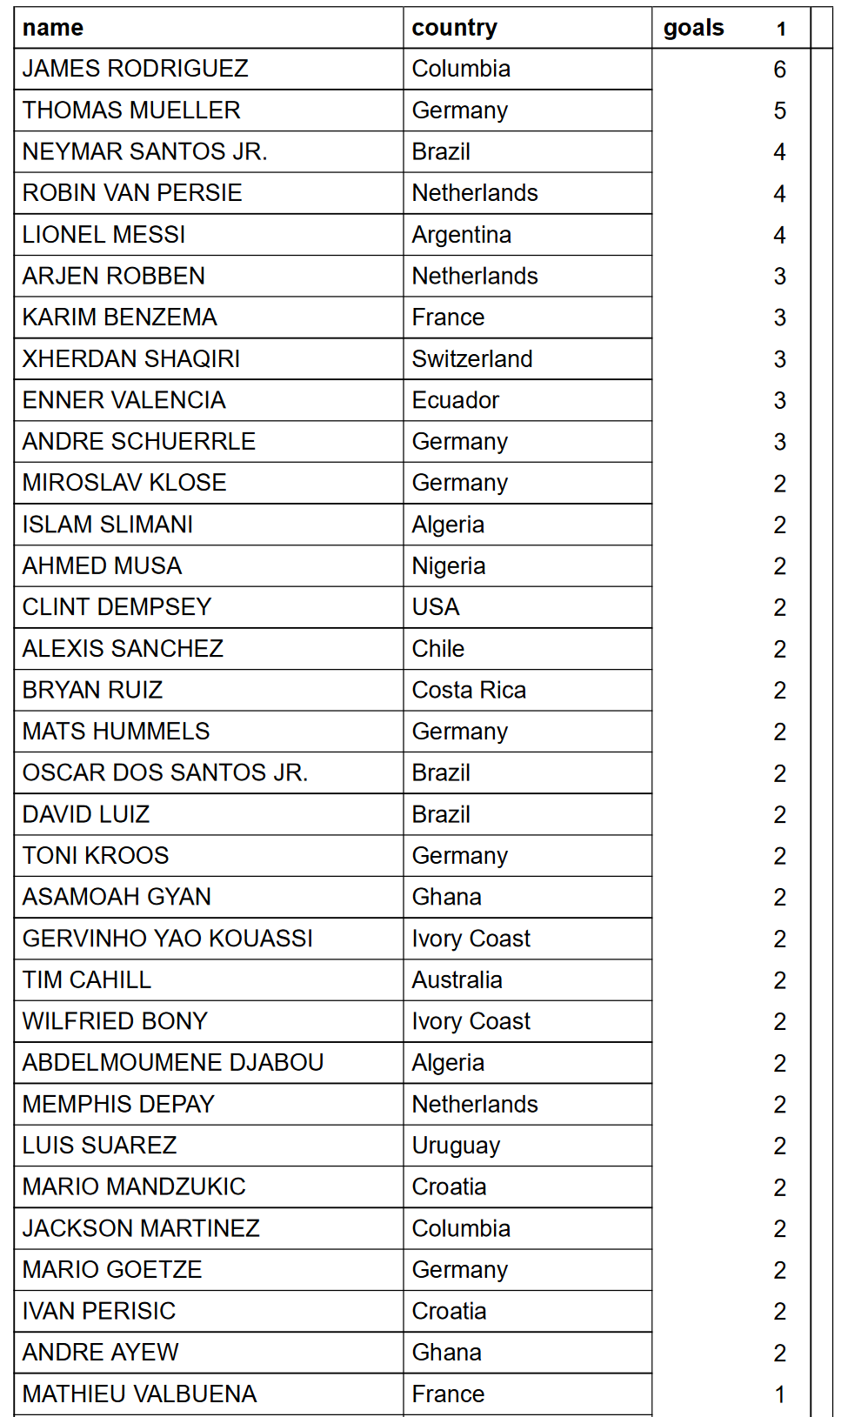

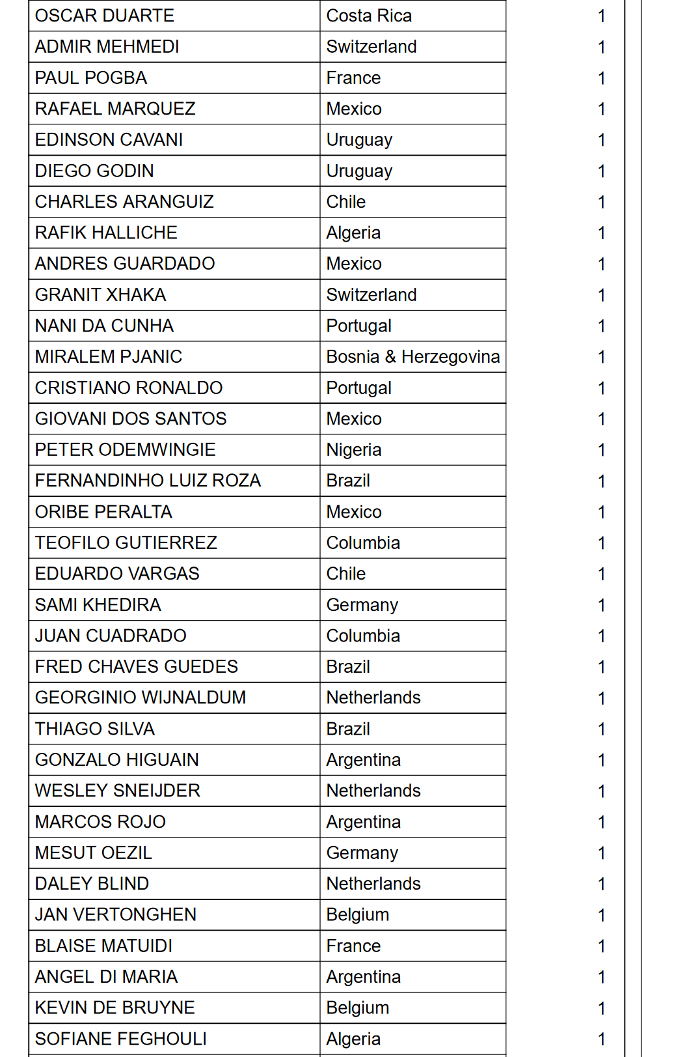

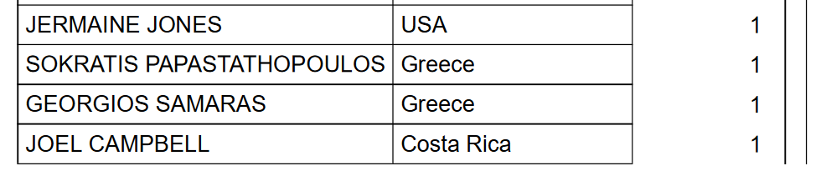

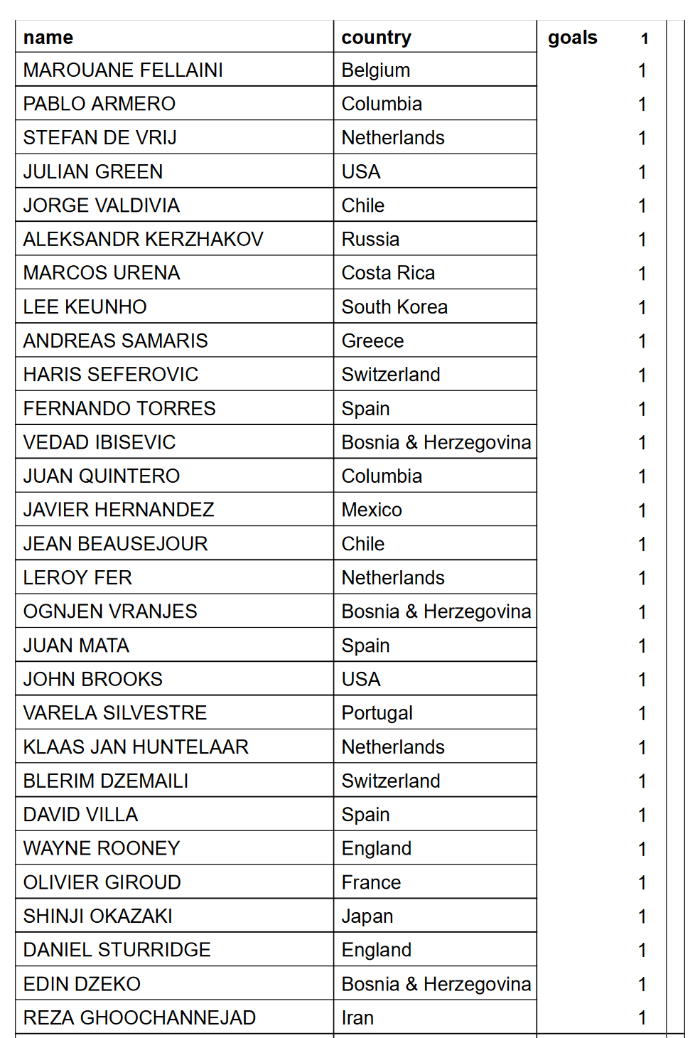

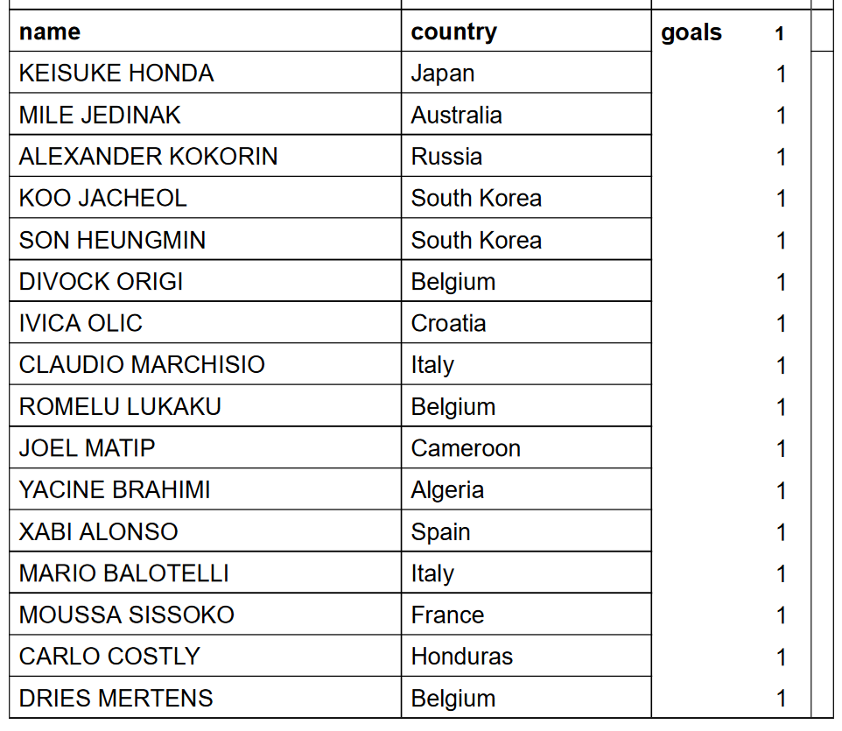

10. Retrieve the name of the players who have scored more than 2 goals, the player’s country, and the number of goals each player scored. Order the results by the number of goals scored in descending order.



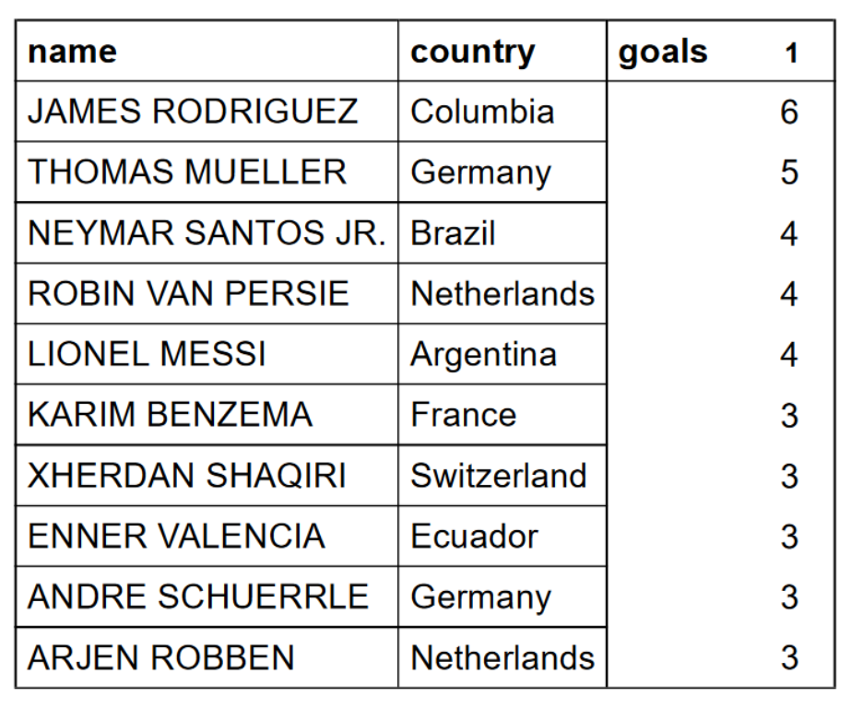

Part 5: Inserting Records that violate integrity constraints

* Violating Key constraint

INSERT INTO country(country_name, population, no_worldcup_won, manager) VALUES ("Australia", 205, 4,"Bob the Builder");

* Violating Entity Constraint

INSERT INTO country(country_name, population, no_worldcup_won, manager) VALUES (NULL, 205, 4,"Bob the Builder");

* Violating Referential Constraint

INSERT INTO player_card(player_id,no_yellow_cards,no_red_cards) VALUES(123456,2,2);

Part 6: Deleting Records that violate referential integrity constraints

DELETE FROM country WHERE country.country_name = "Australia";

Part 7: Inserting Records that do not violate any integrity constraints

* Record 1

INSERT INTO country (country_name, population, no_worldcup_won, manager) VALUES (“Vietnam”,65.3,2,“Nguyen Van Vinh”);

* Record 2

INSERT INTO player_card(player_id,no_yellow_cards,no_red_cards) VALUES (354875,1,2);

* Record 3

INSERT INTO player_assist_goals(player_id,no_matches,goals,assists,minutes_played) VALUES (368902,5,8,3,425);